Khaldoon Qasim
c4021225

5 aside football simulator

Football simulator with custom teams, custom players, random match events and configurable 10 team league.

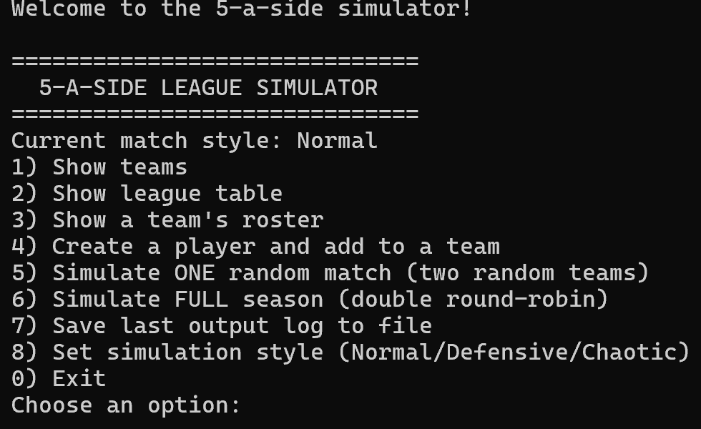
The picture above shows the menu, then the option the user chooses is 1, and the output is shown below
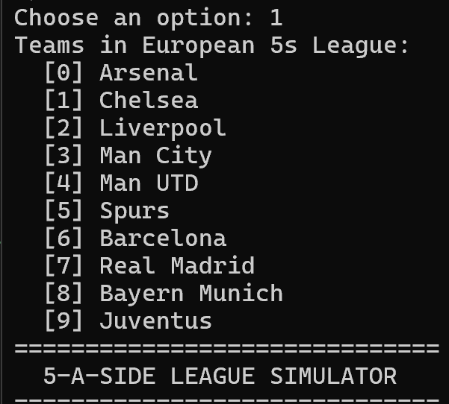
It shows all the teams in the league.

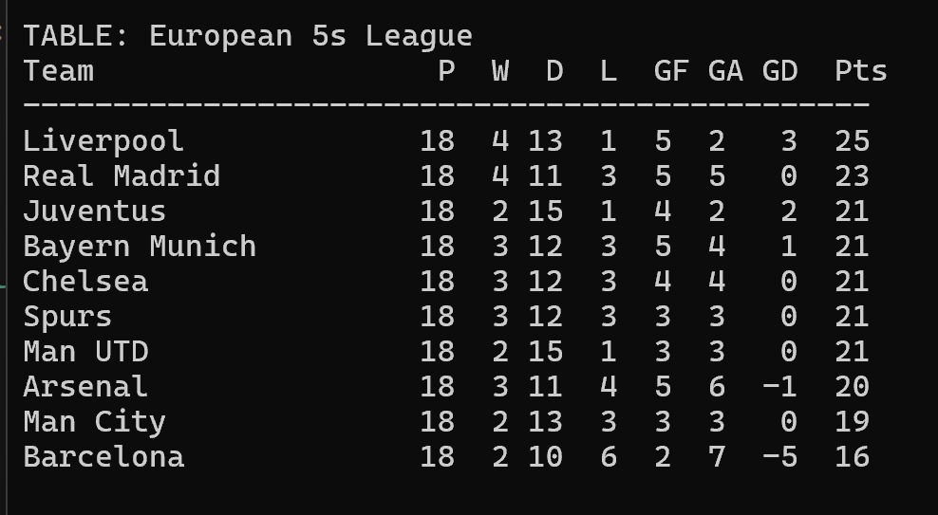
The code above shows the full simulation of the league when entering option 6 of the menu, it shows the randomness of the league.

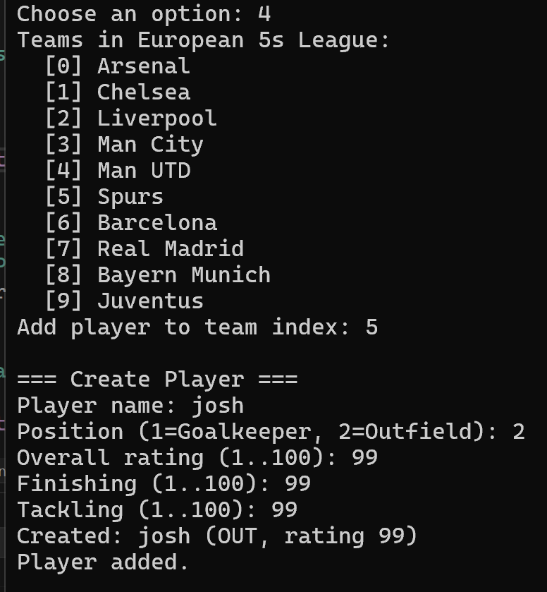
The screenshot above shows adding a custom player to a selected team, I added a player with a high rating to boost their chances.
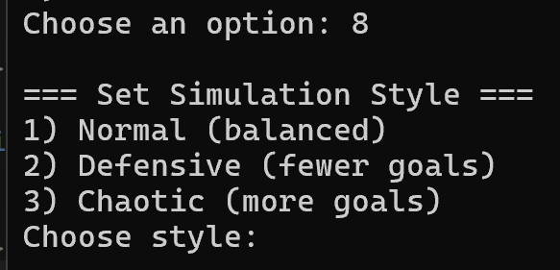
The screenshot above also shows the mode of game that can be selected for the simulation.

AI Transparency Statement (AITS 2 – AI for Shaping)
AI was used for shaping only, shape the initial design and suggest the structure and features of the simulation. All code was written by me, tested by me.

